WEB TECHNOLOGY

LAB 9

ASSIGNMENT

Q1 T1. Develop a currency converter application that allows users to input an amount in one currency and convert it to another. For the sake of this challenge, you can use a hard-coded exchange rate. Take advantage of React state and event handlers to manage the input and conversion calculations.

Note: Everything has to be done using Vue.js

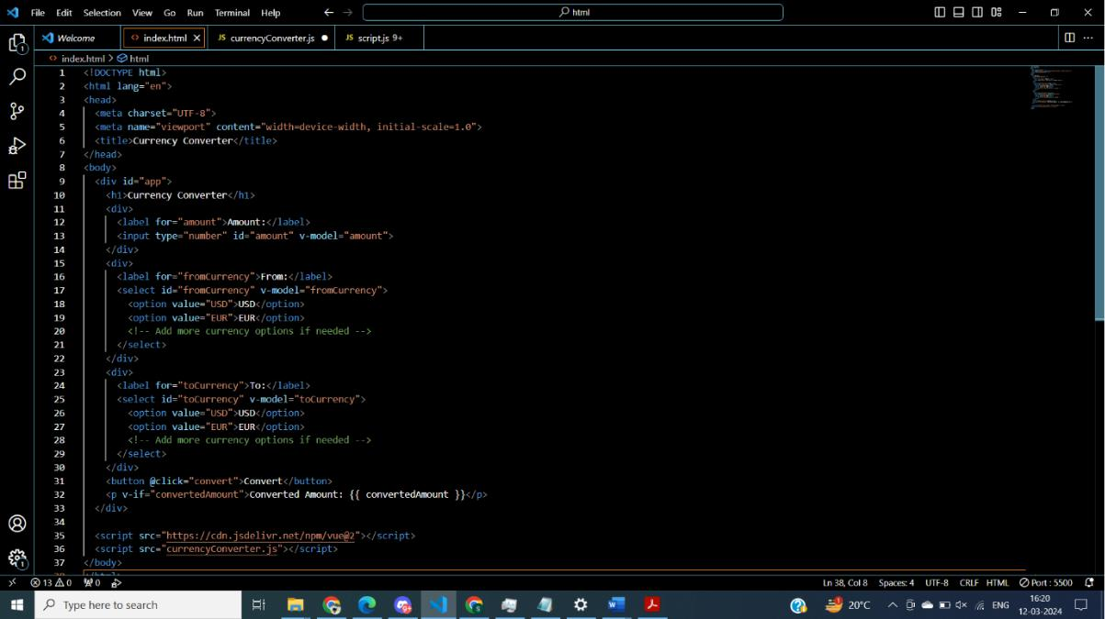

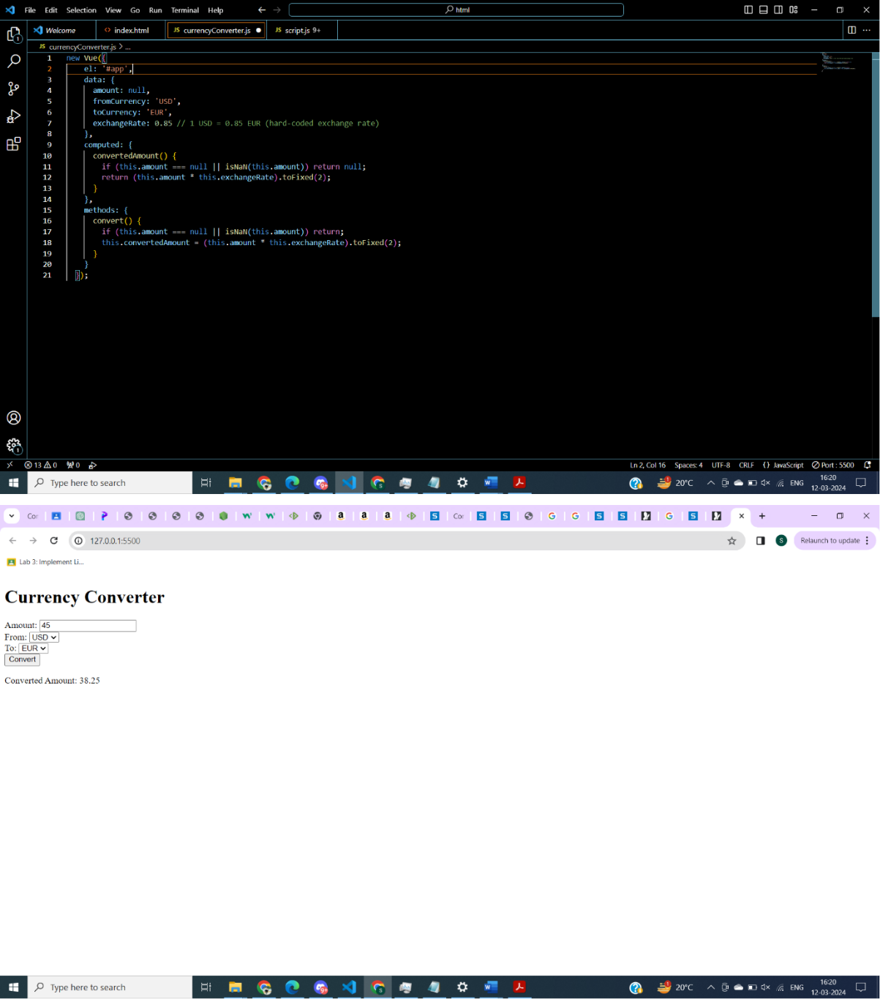

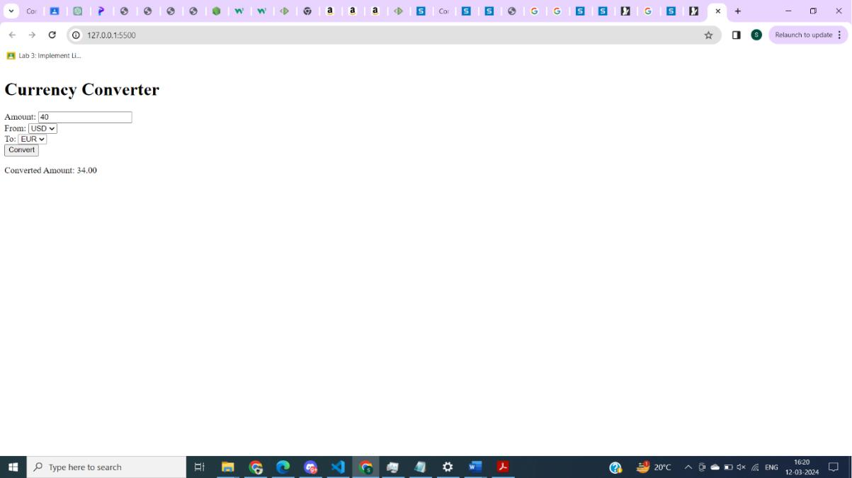

Q2 T2. Create a stopwatch application through which users can start, pause and reset the timer. Use React state, event handlers and the setTimeout or setInterval functions to manage the timer’s state and actions.

Note: Everything has to be done using Vue.js

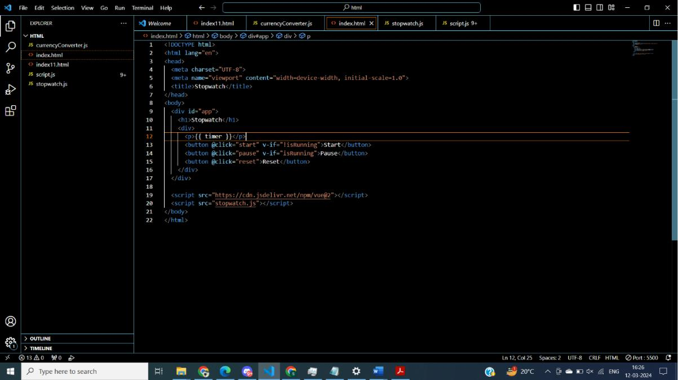

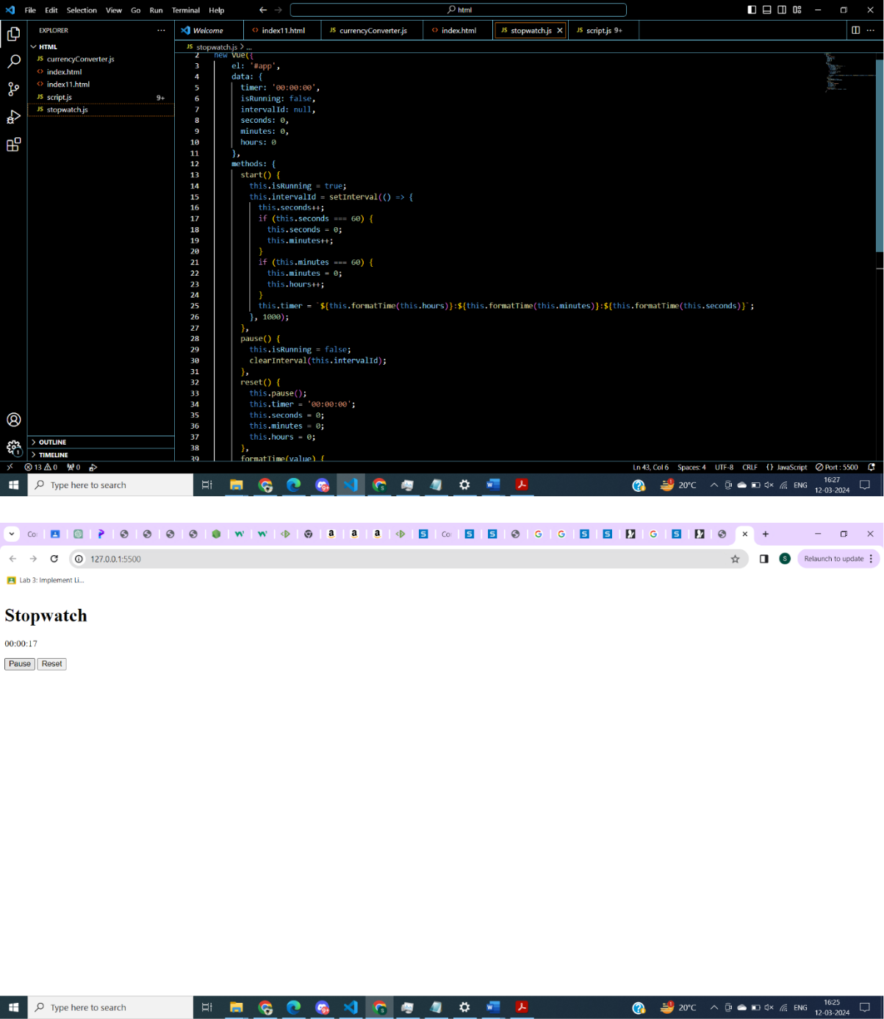

Q2 T3. Develop a messaging application that allows users to send and receive messages in real time. The application should display a list of conversations and allow the user to select a specific conversation to view its messages. The messages should be displayed in a chat interface with the most recent message at the top. Users should be able to send new messages and receive push notifications.

Note: Everything has to be done using Vue.js

